Department of Computer Science and Engineering



**Design Document (DD)**

**Shelf Awareness e-Bookstore**

**-v1.0-**

*Ana Pesko* *ana.pesko@mail.polimi.it*

*Laura Schiatti      laura.schiatti@mial.polimi.it*

*Jefimija Zivkovic,                     jefimija.zivkovic@mail.polimi.it*

July 4th, 2019

**Abstract**

The purpose of this document is to discuss aspects regarding the design and modelling decisions made to develop Shelf Awareness e-Book. It is focused specially on giving details about the Interactive Dialogue Model followed for designing interactive multimedia application. To do so there are provided graphical representation such as *C-IDM* and *L-IDM* schemas and *in-the-small specifications*.

Shelf Awareness is an online BOOK STORE containing paper-based and digital books, their authors and book signing events.

**Graphical representations: C-IDM and L-IDM schemes**

**Textual Descriptions**

* **Single Topic (or Topics)**

1. Ordering and Shipping*:* *general info about how to place orders, delivery process, etc.*
2. Contact Us:  *relevant contacts for this website*

* **Multiple Topics (Kinds of Topic)**

1. Book: *the description of an available book*
2. Author: *the description of an author, writer of one or more books*
3. Event: *the description of the presentation event of a book*

* **Relevant Relationships**

1. Written-by?**:**  Book-->Author [1-1]; *if a book is the subject, you can switch to the corresponding author*
2. Writes?: Author-->Book Key **[1-N]**; *if an author is the subject, you can switch to the books* *written by him*
3. Other similar books?: Book-->Book **[1-N]**; *if a book is the subject, you can switch to the books* *that are similar to it*
4. Where is it presented?: Book-->Event **[1-N]**; *if a book is the subject, you can switch to the events in which it will be presented*
5. Details on book presented here: Event--> Book [1-1]; *if an event is the subject, you can switch to the book being presented on it*

* **Multiple Groups**

1. Books by theme: *the set of books of the same theme T*
2. Books by literary genre*: the set of books of the same genre G*

* **Groups of Topics**

1. Best sellers this month: *those books that where sold the most in the current month*
2. Our favorite readings: *those books that the bookstore considers the most interesting ones for the readers*
3. All events this month*: the complete set of events taking place in the current month*
4. All themes (*grouping all groups\**)*: the complete set of themes of books are available in the bookstore*
5. All literary genres (*grouping all groups\**): *the complete set of literary genres of books are available in the bookstore*
6. All authors*: the complete set of authors whose books are available in the bookstore*

**C-IDM schema**

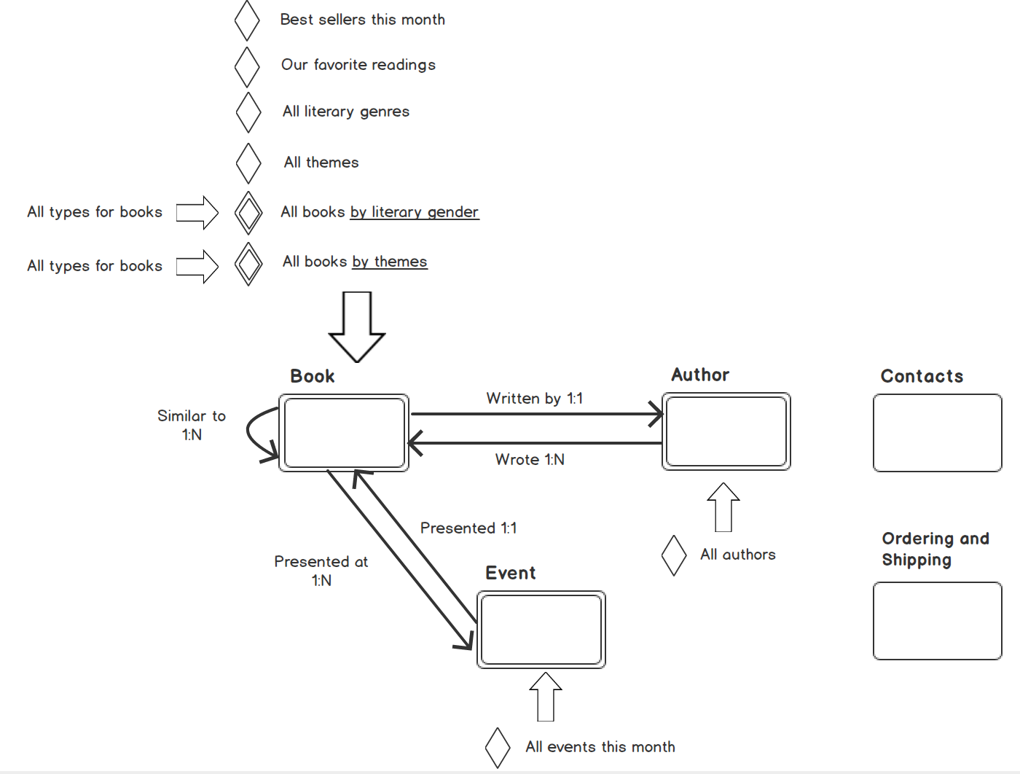

Figure 1. *C-IDM schema* for Shelf Awareness App

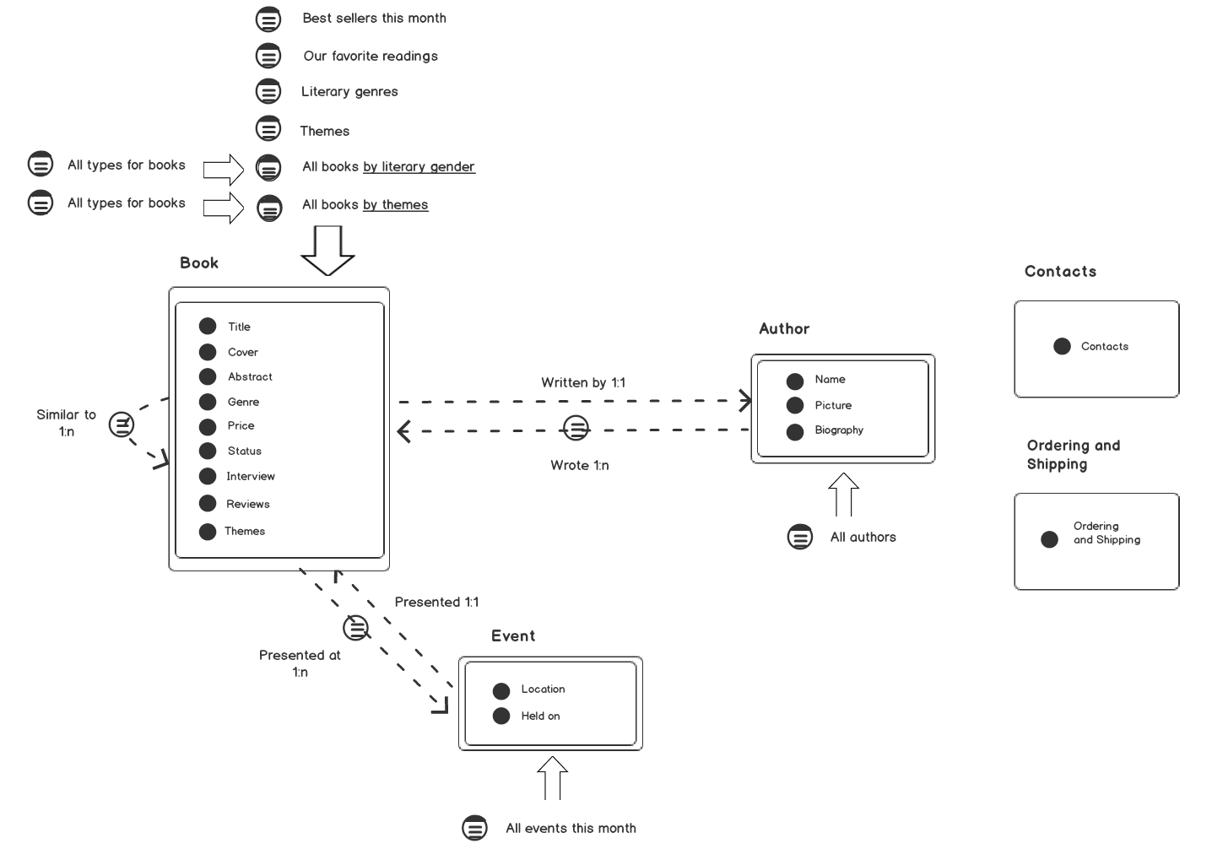**L-IDM schema**

Figure 2. *L-IDM schema* for Shelf Awareness App

**Scenarios**

**Scenario 1:** Book Reservation

* ***Description:*** Andrea already registered on the website and wants to get a fantasy book among those available in the system.
* ***Execution steps:***  Andrea needs to
  1. 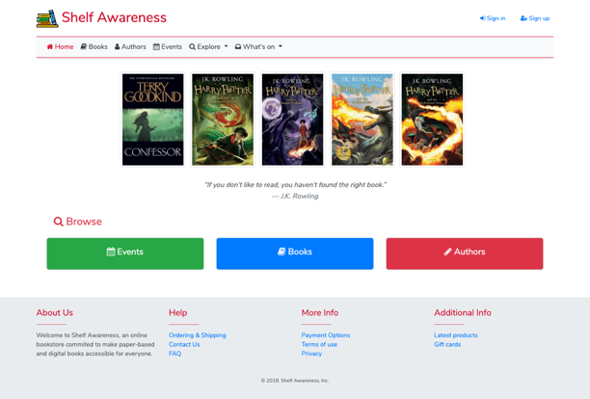Login into the system, access the form and fill it up.

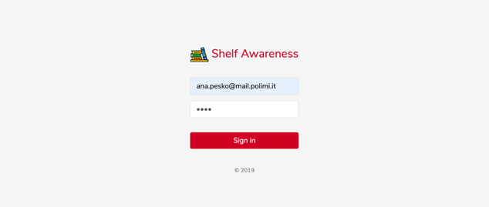

* 1. Search book by literary genre (by means of “explore” landmark)

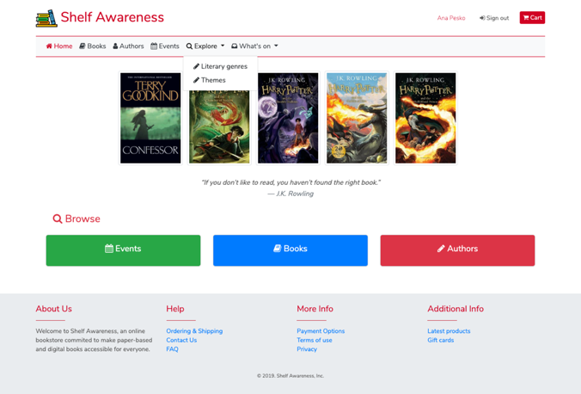

* 1. Select the book he prefers

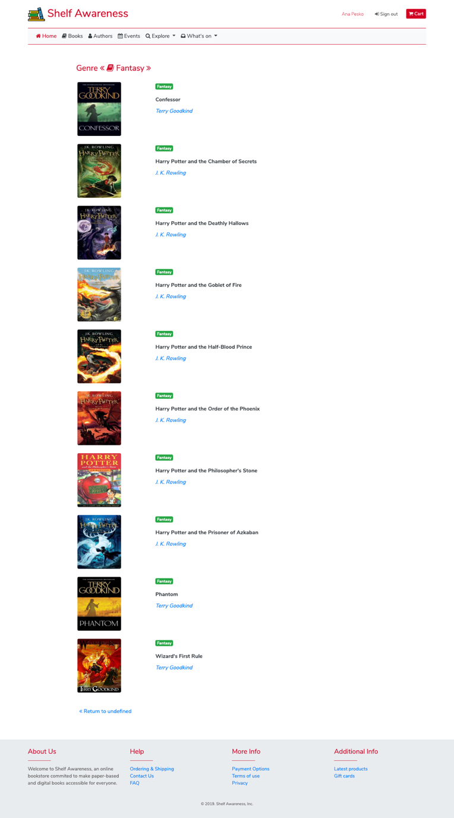

* 1. Add the chosen book to his cart

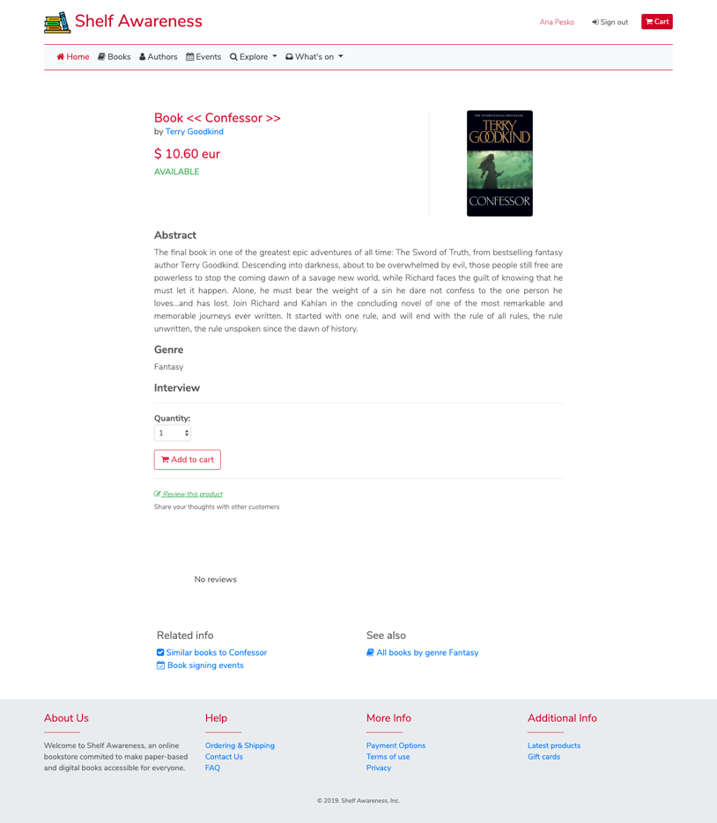

* 1. Check his cart and purchase (functionality not implemented)

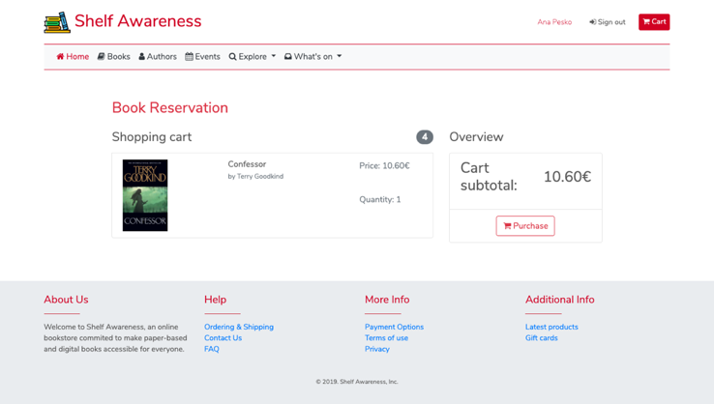

**Scenario 2:** User Registration

* ***Description*:** Carlo wants to register into the system to have access to books available in the system.
* ***Execution steps:*** to do so, Carlo needs to
  1. Access the website

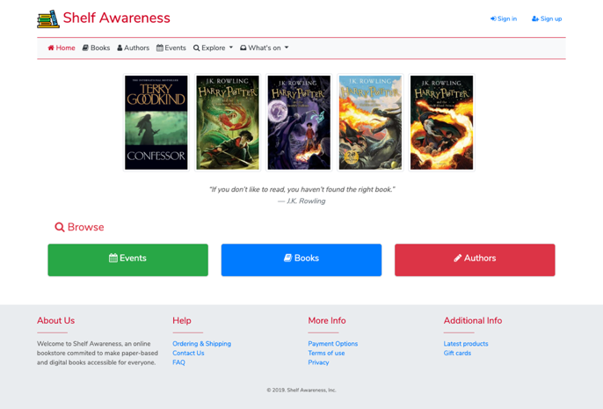

* 1. Submit the registration form

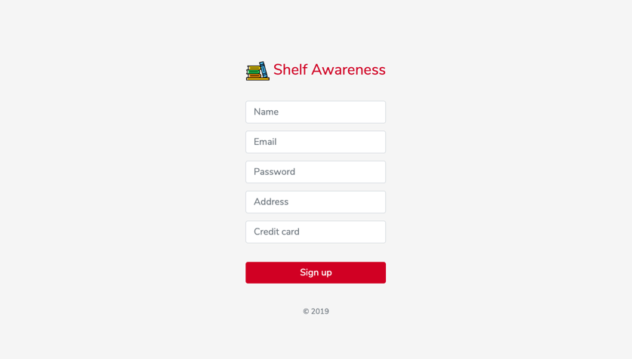

**Scenario 3:** Check events of a given book

* ***Description*:** Laura wants to check upcoming events regarding her favorite book, “*Harry Potter and the Deathly Hallows”*
* ***Execution steps:*** to do so, Laura needs to
  1. Access the list of books, she is not sure about the genre so she looks for it by means of “Books” landmark

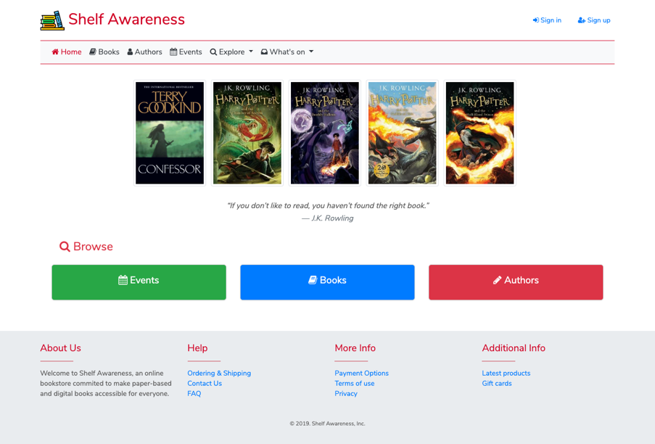

* 1. Click on the read more button

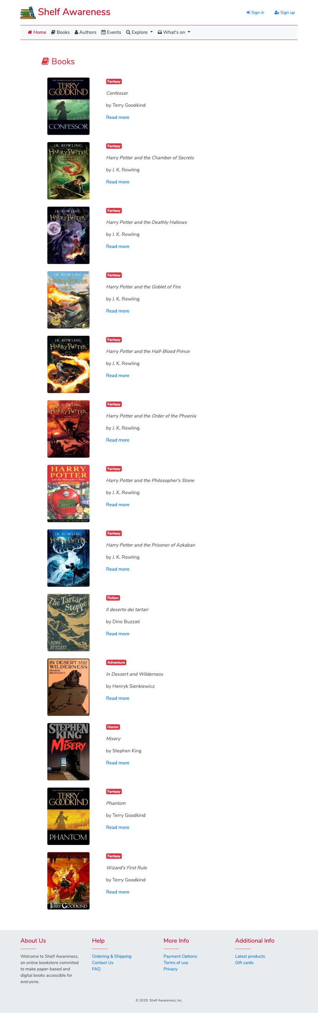

* 1. Scroll down to check the link of “*book signing events”*

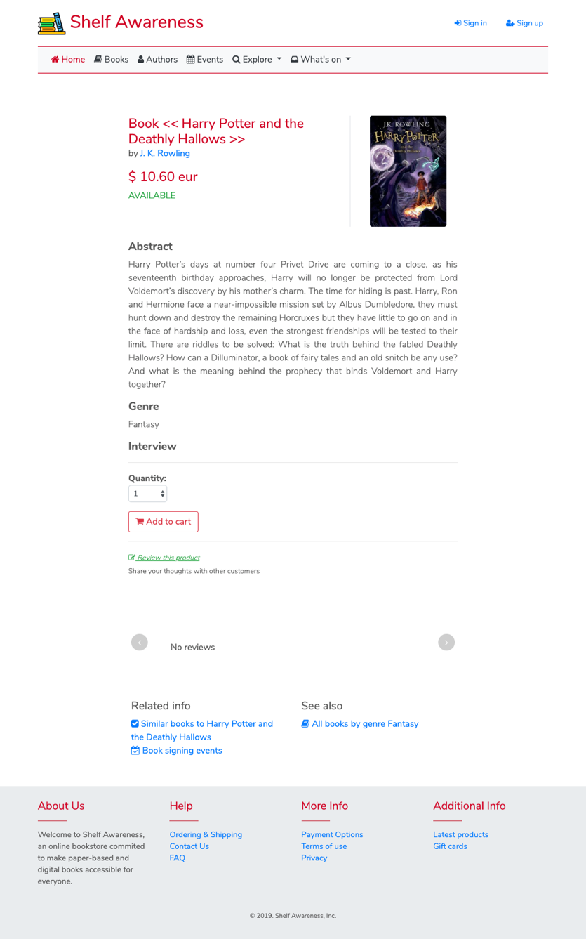

* 1. Check date, time and location of the upcoming book signing events of the book

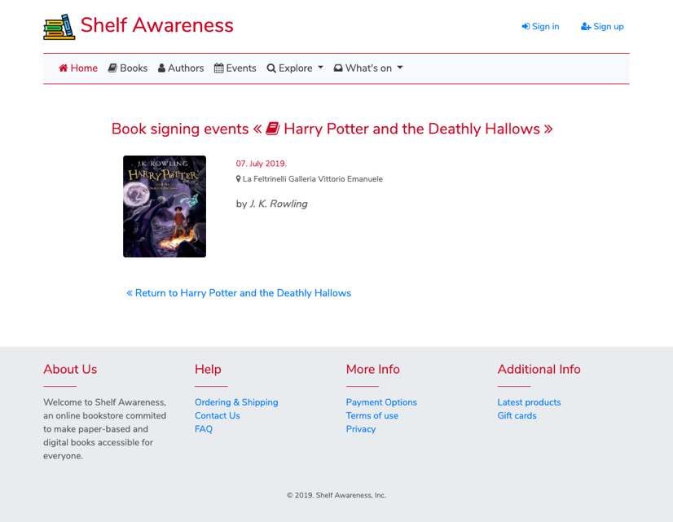

**Design-in-the-Small**

The complete list of all the pages in the P-IDM are listed next classified according to their type.

* **Page structure (in the small) for a Topic Page** *(Single Topics)*

In this category there are pages for ordering and shipping and contact us.

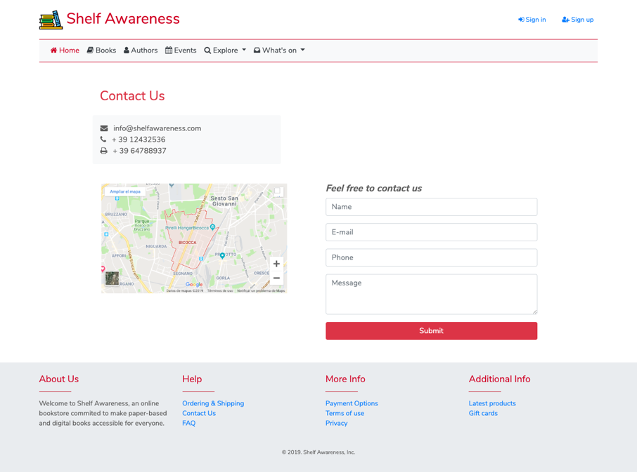

**Landmarks**

Figure 3. *contact_us.html* commented screenshot

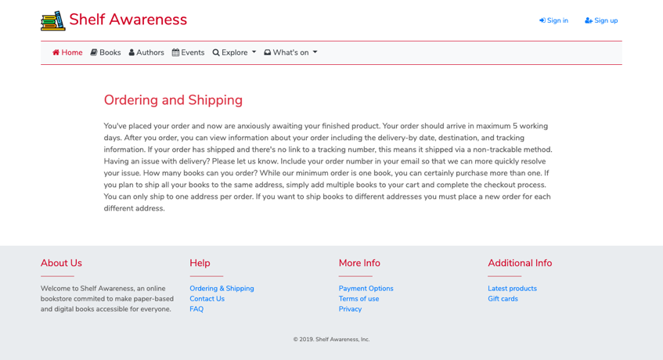

**Landmarks**

Figure 4. *ordering_and_shipping.html* commented screenshot

* **Page structure for a Kind of Topic Page** *(Multiple Topics)*

In this category there are pages for a given author, book and event.

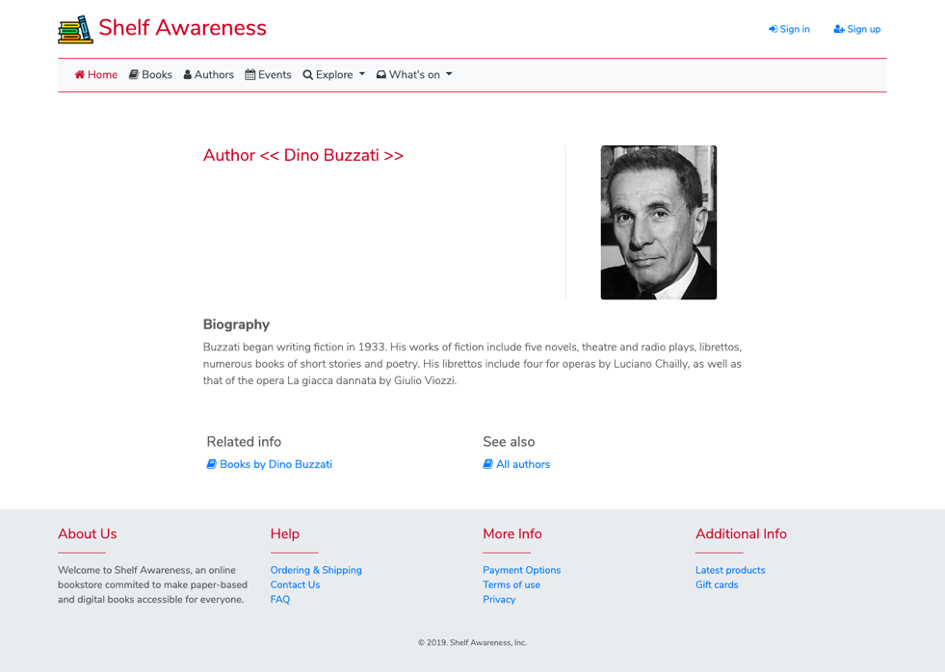

**Landmarks**

**Orientation info**

**Transition links**

**Group links**

Figure 5. *author.html* commented screenshot

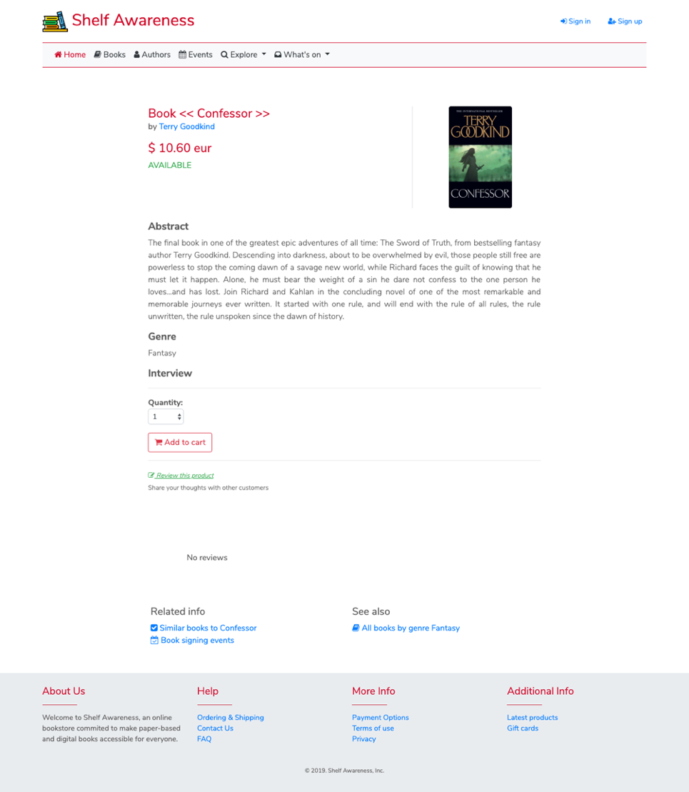

**Orientation info**

**Transition links**

**Group links**

**Structural link**

**Landmarks**

Figure 6. *book.html* commented screenshot

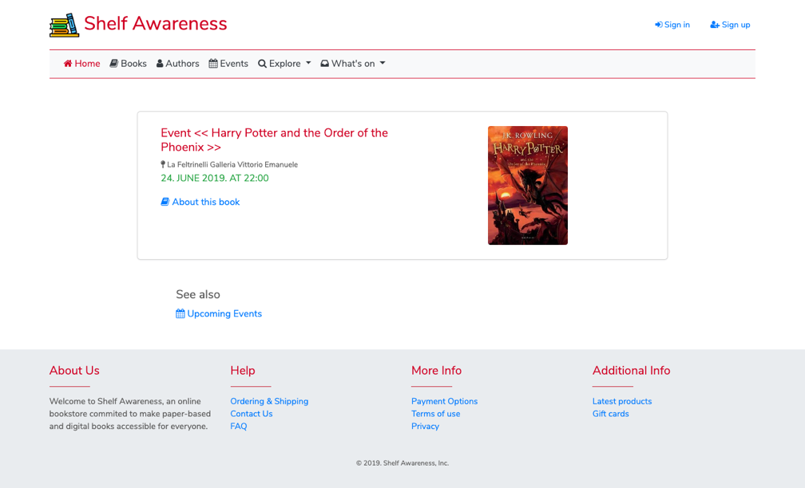

**Group links**

**Structural link**

**Orientation info**

**Landmarks**

Figure 7. *event.html* commented screenshot

* **Page structure for a Transition Page** *(1:N Relevant Relationships)*

In this category there are pages for each 1-N relevant relationship, this means, for books of a given author, and similar books and events associated to a book

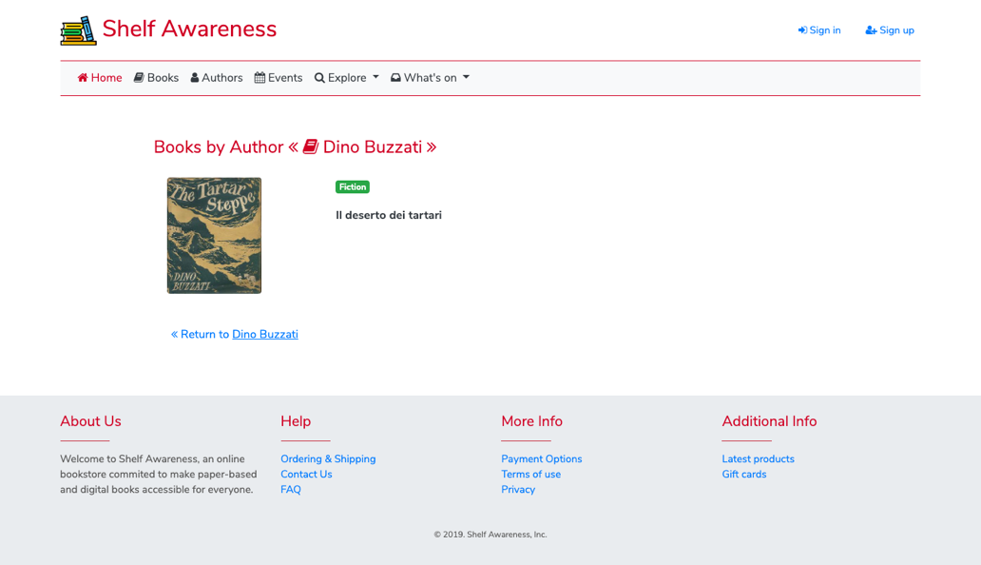

**Landmarks**

**Orientation info**

**Transition links**

Figure 8. *books_by_author.html* commented screenshot

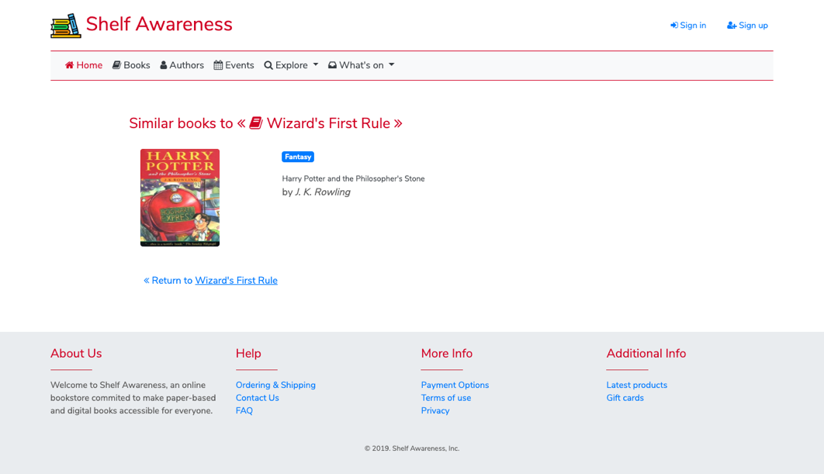

**Orientation info**

**Transition links**

**Landmarks**

Figure 9. *similar_books.html* commented screenshot

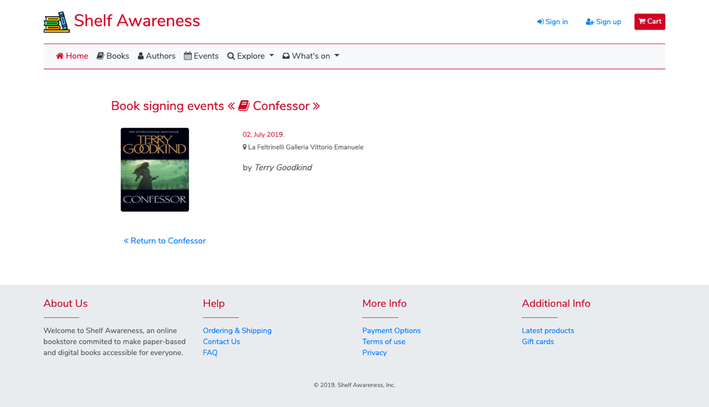

**Transition links**

**Landmarks**

**Orientation info**

Figure 10. *events_by_book.html* commented screenshot

* **Page structure for a the Introductory Page** *(Groups of Topics)*

In this category there are pages regarding groups of topics, as best sellers, or all themes.

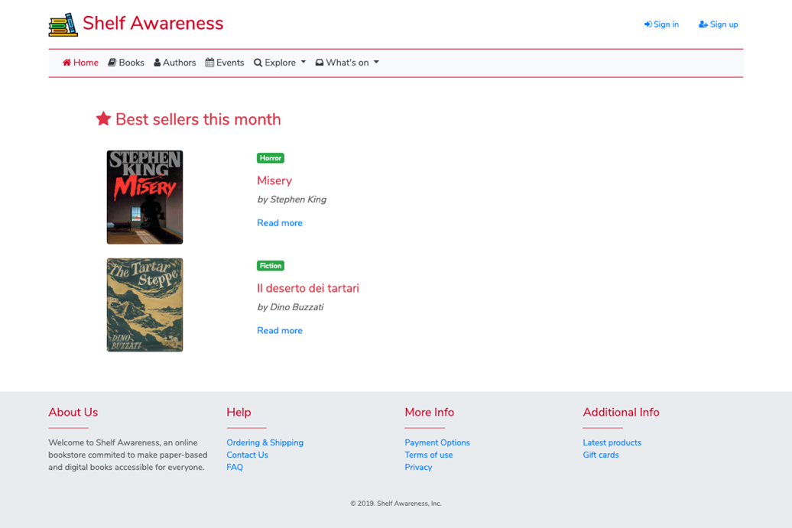

**Group links**

**Landmarks**

Figure 11. *best_sellers.html* commented screenshot

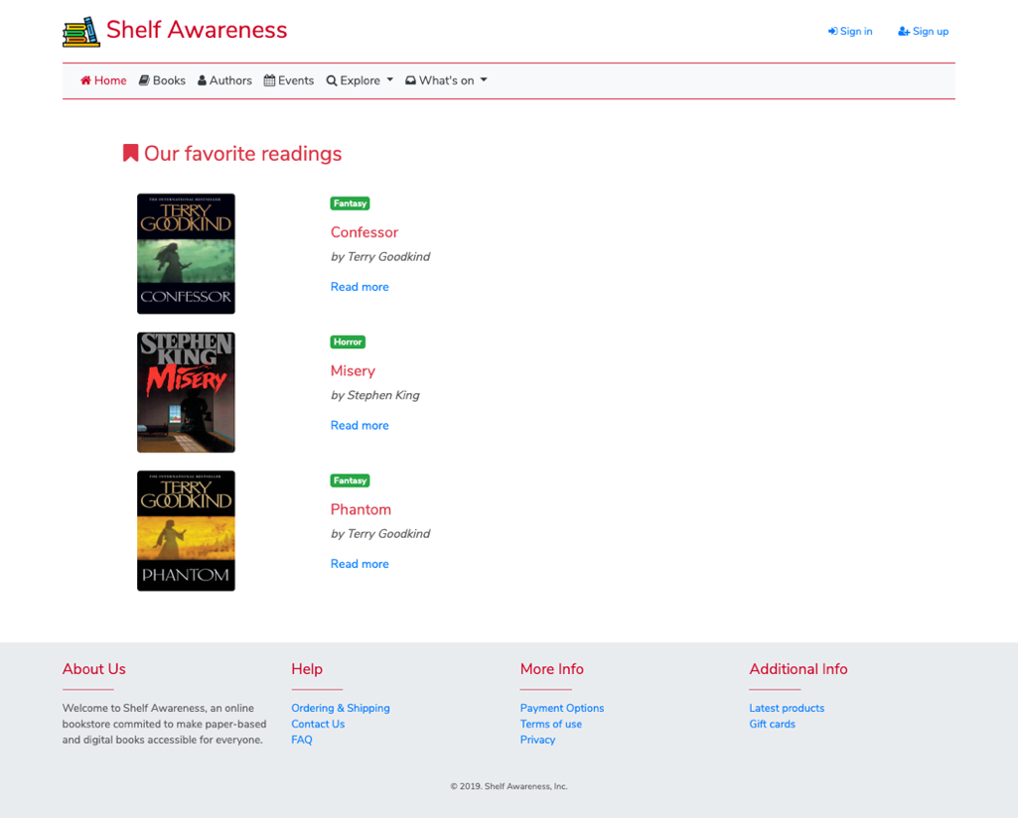

**Group links**

**Landmarks**

Figure 12. *favorite_readings.html* commented screenshot

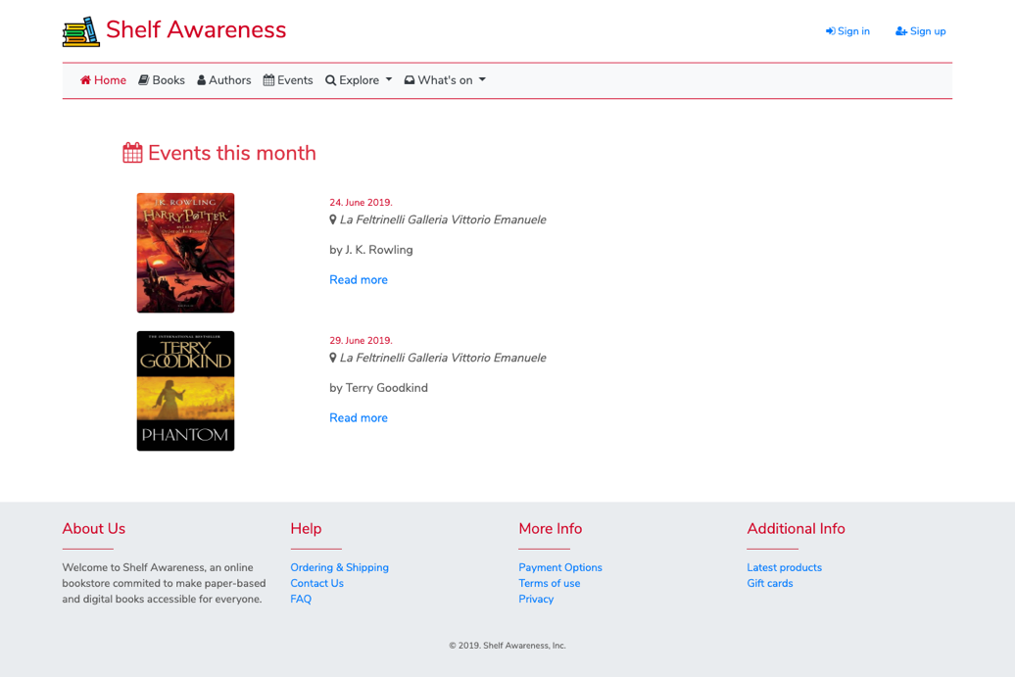

**Group links**

**Landmarks**

Figure 13.*events_this_month.html* commented screenshot

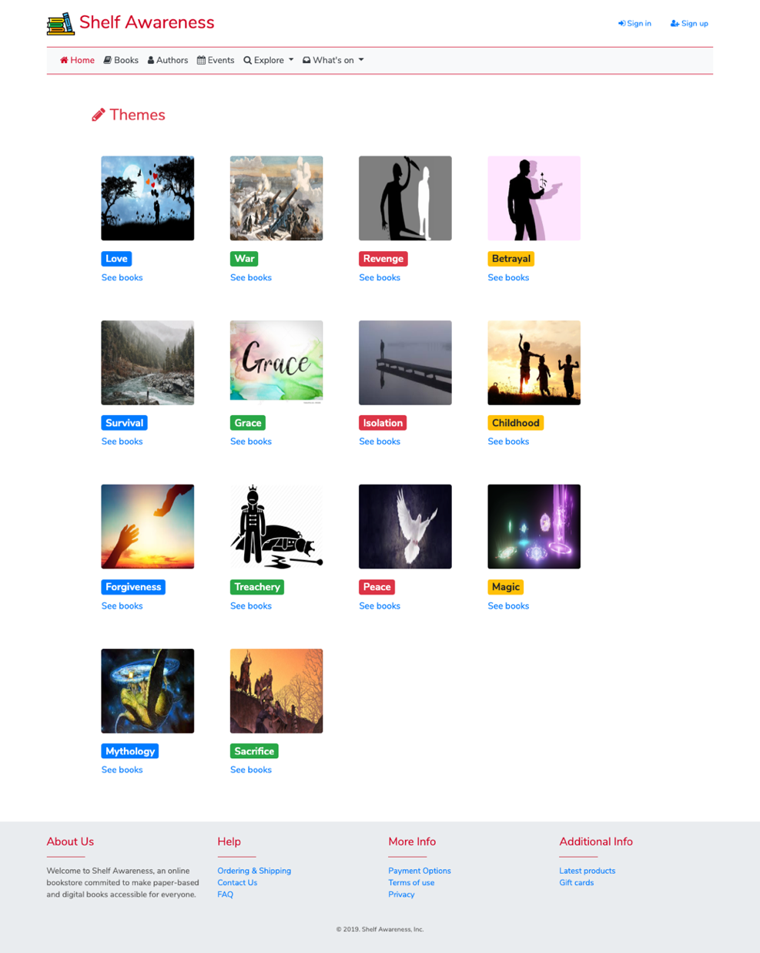

**Group links**

**Landmarks**

Figure 14.*all_themes.html* commented screenshot

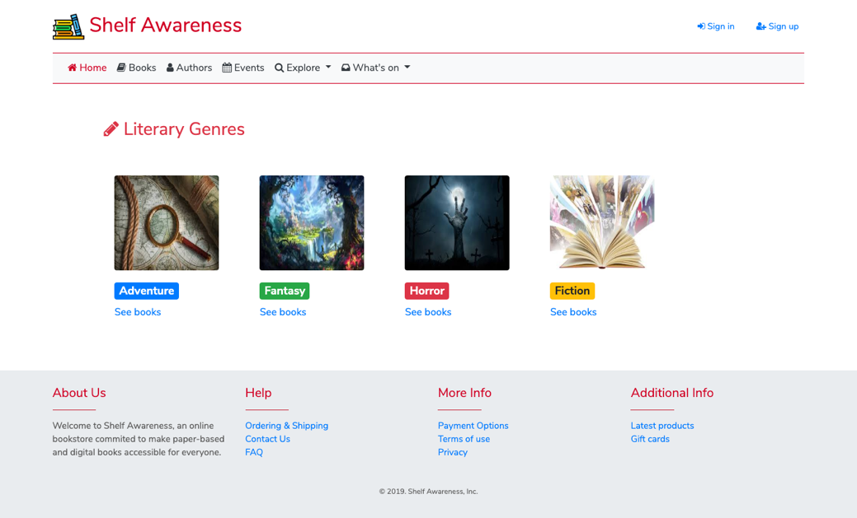

**Group links**

**Landmarks**

Figure 13.*all_literary_genres.html* commented screenshot

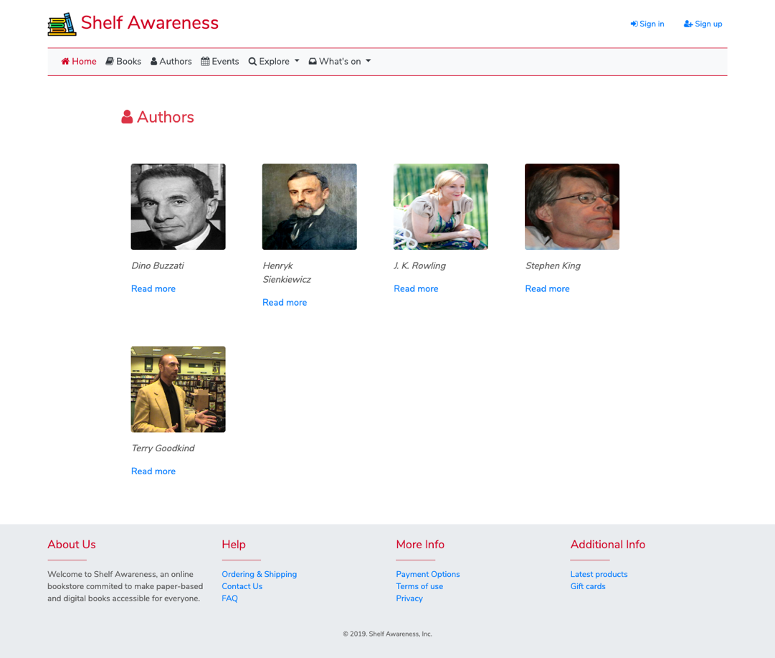

**Landmarks**

**Group links**

Figure 14.*all_authors.html* commented screenshot

* **Page structure for a the Introductory Page** *(Multiple Groups of Topics)*

In this category there are pages regarding groups of topics, as best sellers, or all themes.

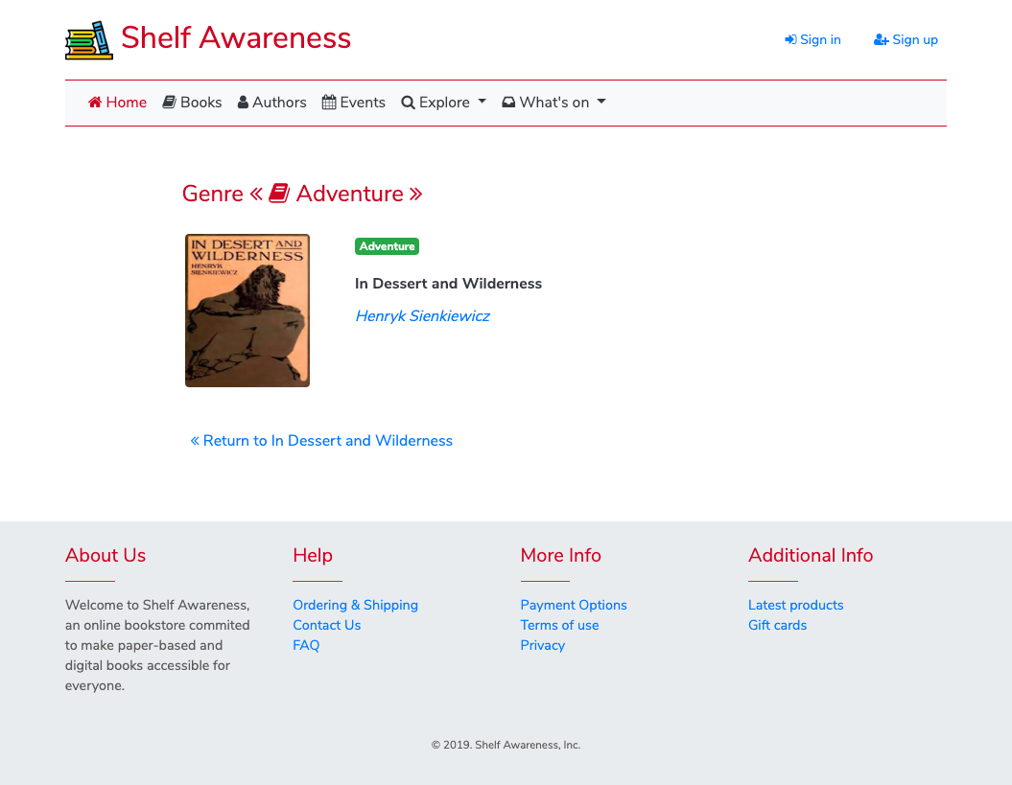

**Group links**

**Landmarks**

**Orientation info**

Figure 16. *all_books_by_genre.html* commented screenshot

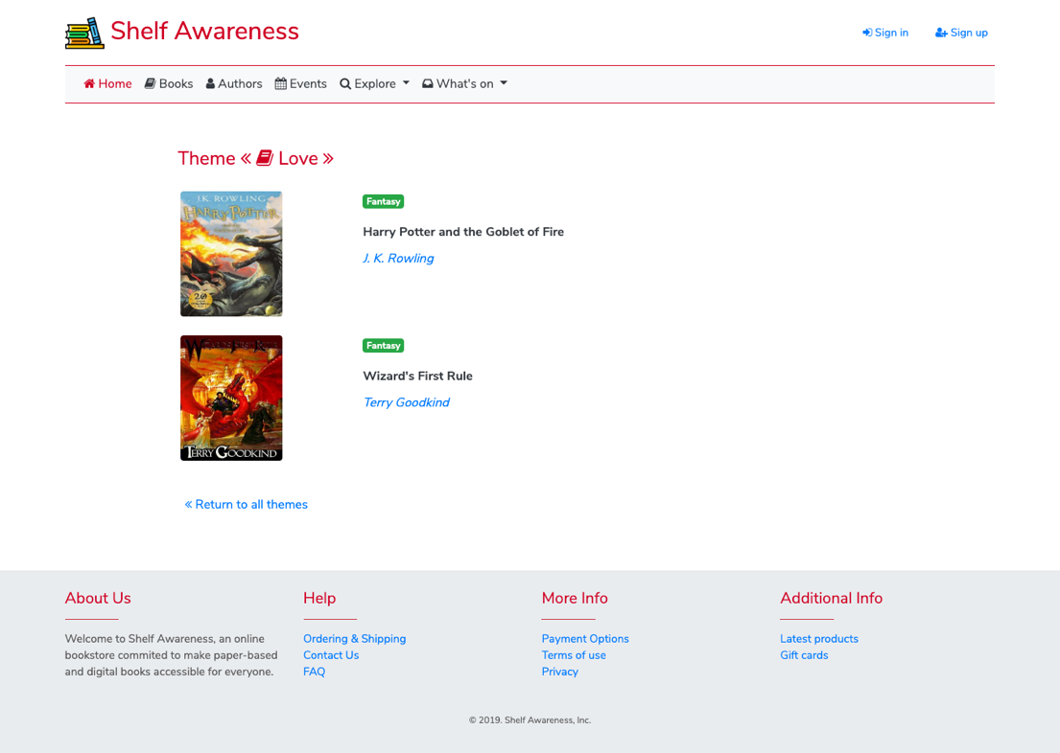

**Orientation info**

**Group links**

**Landmarks**

Figure 17. *all_books_by_theme.html* commented screenshot

**DB Design**

**Highlights**

* The E-R diagram contains the main entities considered in the app, these are books which are related to authors, events, reviews and similar books.
* There are also users that can access to reservation and reviews functionalities.
* The books a user adds to his cart are stored on an associated a table.
* Books can have several themes but only one genre, this is the reason why the genre is an attribute in the books table.

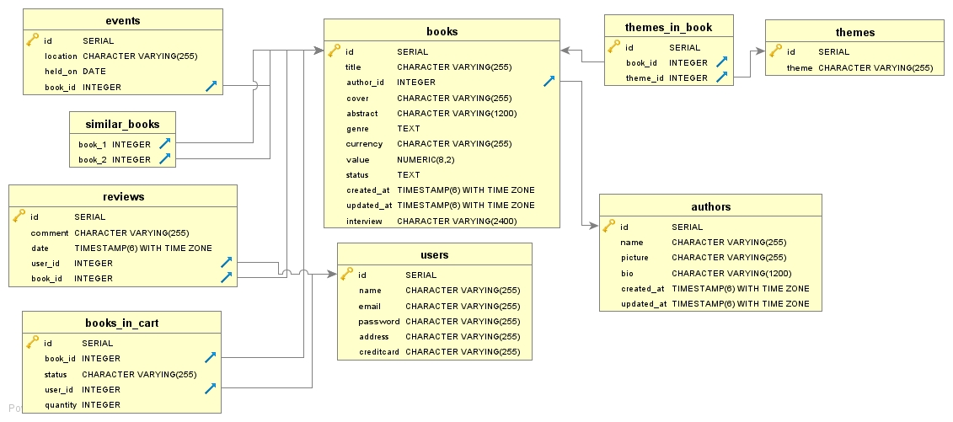

Figure 19. E-Rdiagramfor Shelf Awareness App

**Relational Tables for the main pages**

|  |  |
| --- | --- |
| **Page** | **Relational Tables** |
| Book - *book.html* | authors - books |
| Author - *author.html* | authors |
| Event - *event.html* | Authors – Books - Events |

|  |  |
| --- | --- |
| Writes - *books_by_author.html* | authors – books |
| Similar Books - *similar_books.html* | similar_books |
| Where it is presented? - e*vents_by_book.html* | books – authors - events |

|  |  |
| --- | --- |
| Best sellers this month *best_sellers.html* | books_in_cart – books - authors |
| Our favorite readings *favorite_readings.html* | authors – books |
| All Events this month *events_this_month.html* | books – authors - events |
| All Themes *– all_themes.html* | themes |
| All Literary Genre – *all_literary_genres.html* | authors – books |
| All Authors – *all_authors.html* | authors |

|  |  |
| --- | --- |
| All Books by Literary Genre X *all_books_by_genre.html* | authors - books |
| All Books by Theme X *all_books_by_theme.html* | authors – books – themes_in_book |